IT IS 2300 Homework 1 – Web Application Proposal

Michael’s Developer Portfolio

**Description / Overview**: The purpose of this project is to develop a web-based portfolio to showcase the development skills of a friend of mine, Michael. He is a C++/Unix programmer and currently a research student for the university but does not have a formal portfolio to present his skills to potential employers. This would be good for him as he will be graduating before long with his Master’s degree and will need a showcase of his skill.

The content on the pages will consist of information gathered from Michael, such as information about his interests and hobbies, images and descriptions of his professional works, and contact information so that potential employers may get in touch with him. All of this information will be gathered from him during an informal interview, and will be organized by myself into web pages.

Site Map:

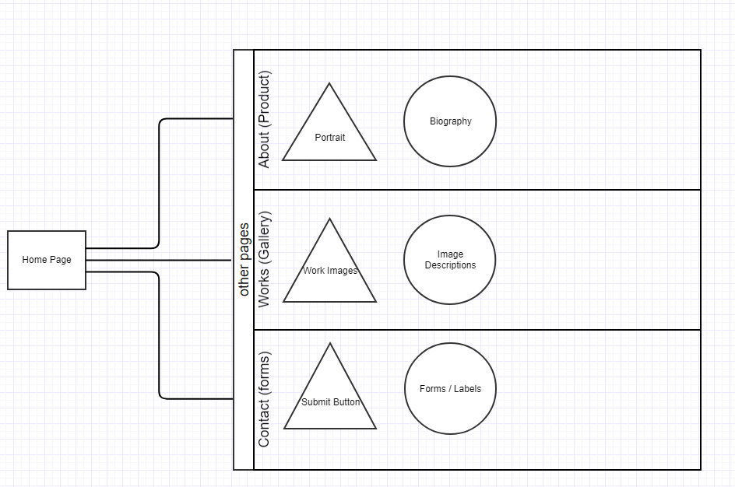

**Users and Stakeholders**: The sole stakeholder of this site will be my friend Michael, who this will represent. Anyone that would view his page with the intent of learning more about him, such as a job recruiter, would also be a user of this page, but obviously I won’t be able to contact them with inquiries. For this reason, I will only be talking to Michael for this project, but I’ll make sure to get enough input from him to make sure it’s up to his standards.

**Dynamic Functionality**: I would like to make this page capable of being deployed to a live server, which I would do through the use of NodeJS to build a server. I’m not entirely sure this will be doable with my schedule, so instead I will probably just write an image viewing script for the gallery to open an image and display the description in a modal-esque view. I may write a script to handle a dynamic background as well to make the page more aesthetically pleasing. I am considering building a local server to serve the static files (or template-built pages and static files), which would be deploy *ready* but not live to the web. I will decide this later on once I have a better grasp of time constraints.

* Potential 1: Static pages, HTML/CSS/JS with functionality to display gallery images with descriptions in a popup/modal style.
  + Fulfills standard requirements
* Potential 2: Template built pages (EJS) served via NodeJS server with static CSS and JS served alongside for functionality listed in Potential 1.
  + For this option, I would like to request extra credit.
* Potential 3: Deploy to remote linux distribution via hosting service (DigitalOcean) and purchase domain name (Google domain), route IP of server to domain and make fully web-accessible
  + This potential is unlikely due to time commitment. For this option, I would like to request substantial extra credit.